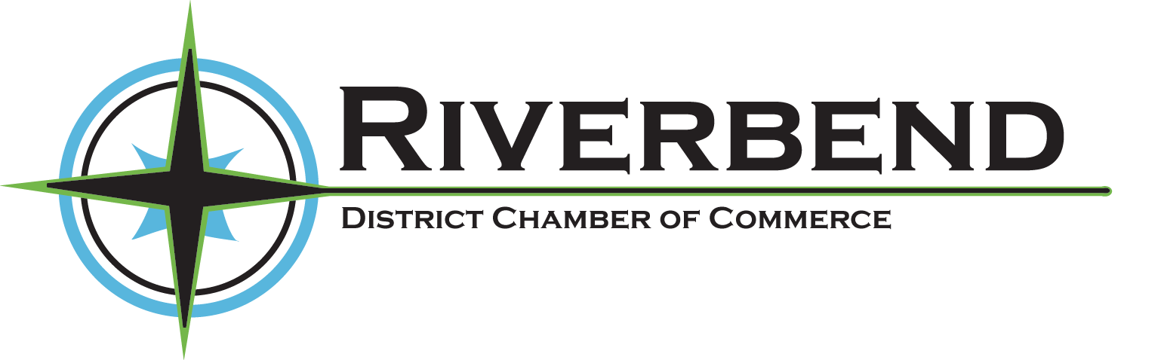

Membership Application

The annual membership dues remain are $30.00 for Corporate membership and $15.00 for an Individual membership.

Please return your membership application along with your membership dues to the Riverbend District Chamber of Commerce, PO Box 397, Radisson, SK, S0K 3L0. Memberships are renewable annually.

Thank you in advance for your continued support and cooperation. Should you wish to participate by volunteering on a Chamber committee, please select the committee you wish to serve on below.

Please print legibly, remove the bottom portion & attach with remittance.

Corporate Membership ($30) Individual Membership ($15)

Business/Corporation Name: ___________________________________
Contact/Representative Name: __________________________________
Business Telephone # ______________________
Cellular #________________________________
Street Address________________________________________________
Mailing Address/ P.O. Box _____________________________________
Town _______________________ Postal Code ____________________
E-mail Address ____________________________________________________________
By providing my e-mail address I agree that the Chamber and its sub-committees may use it to contact me about meetings, and other information it wishes to relay to the membership.

I would like more information about volunteering on the following committee(s):
Public Relations & Promotions Committee Nomination Committee
Membership & Ambassador Committee Tourism Committee
Advocacy & Economic Development Committee

